I have completed entire program. Steps have been mentioned below

* Generating unigrams along with a frequency
* Generating bigrams along with a frequency
* Calculating Chi Square test for all bigrams
* Calculating PMI test results for all bigrams

Had to run PMI on Jupyter and Chi Square on SPYDER IDE as it was taking much time on a single IDE. So, I have attached the same results.

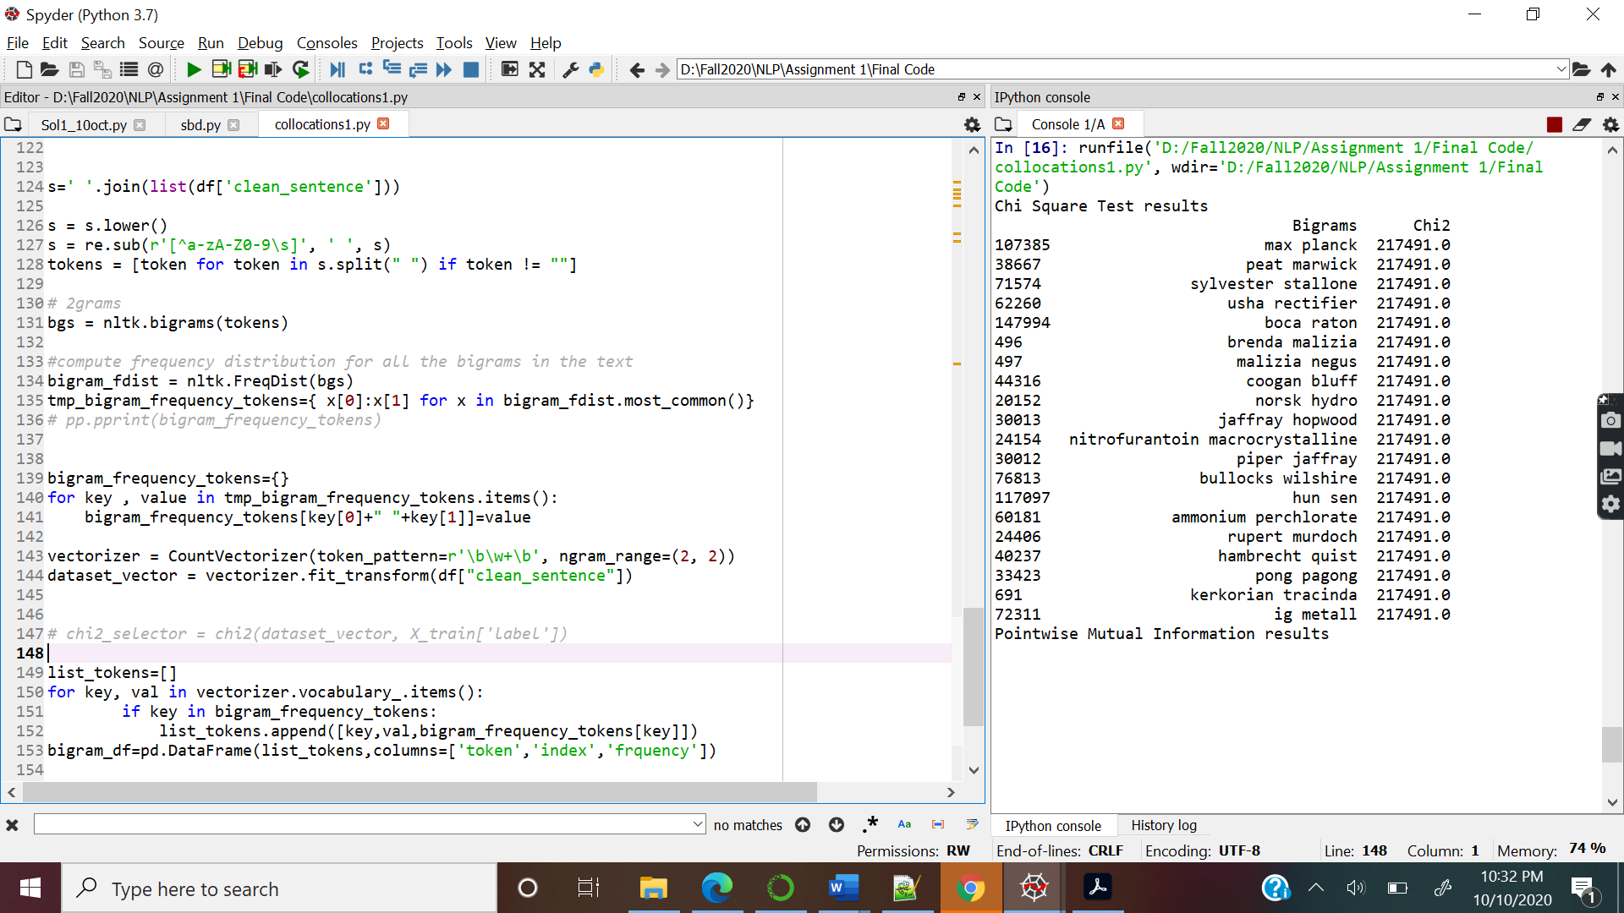

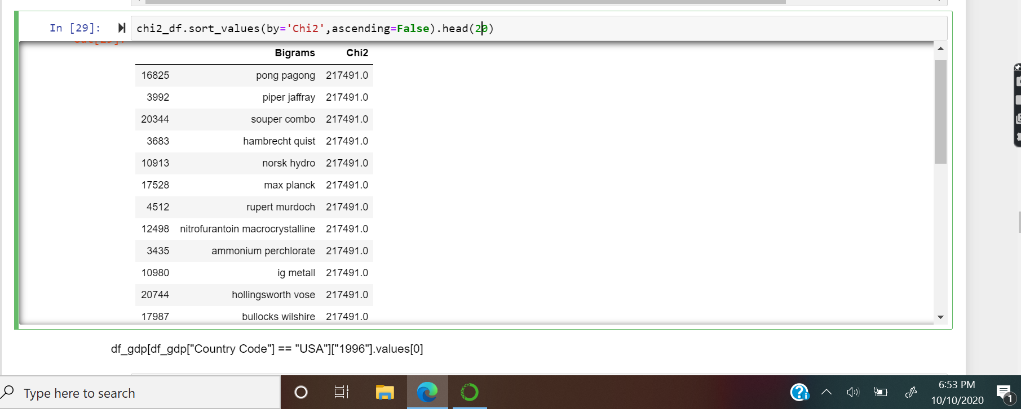

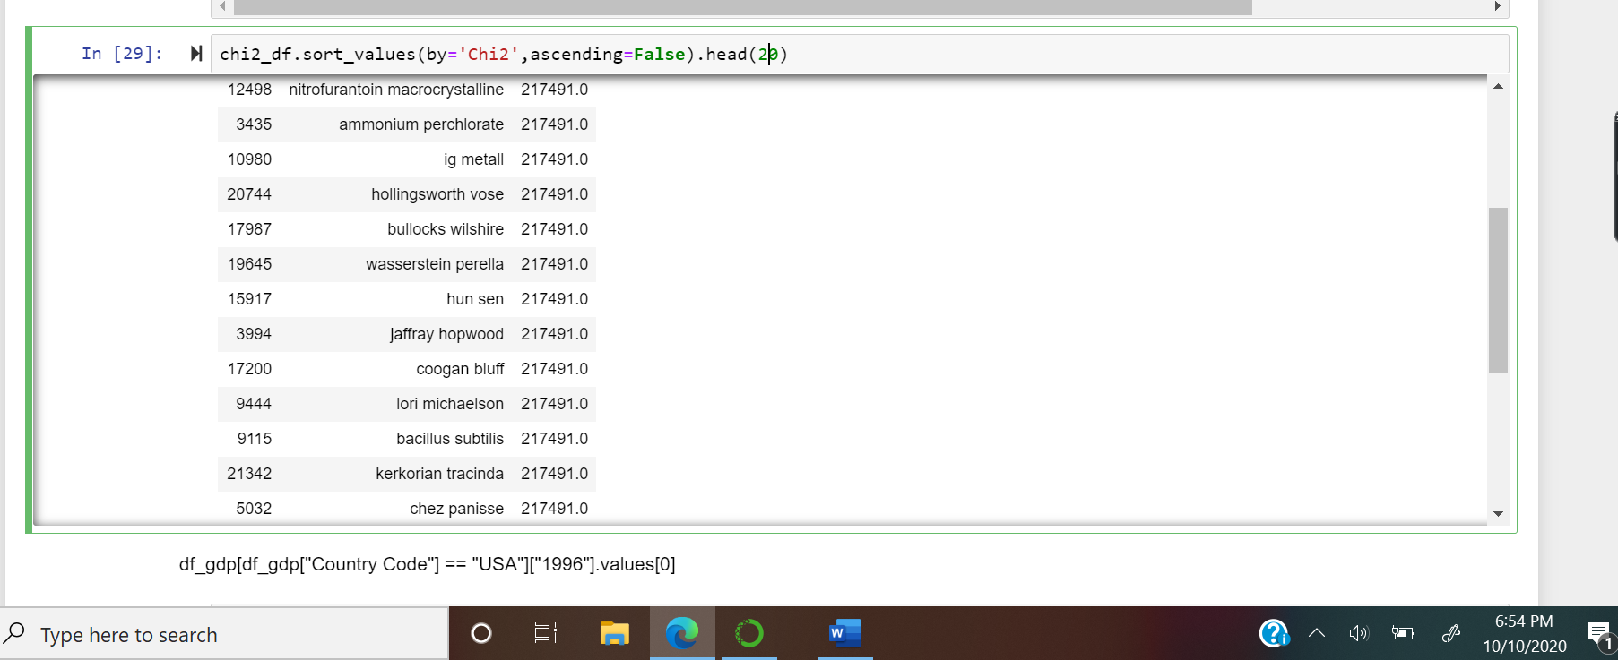

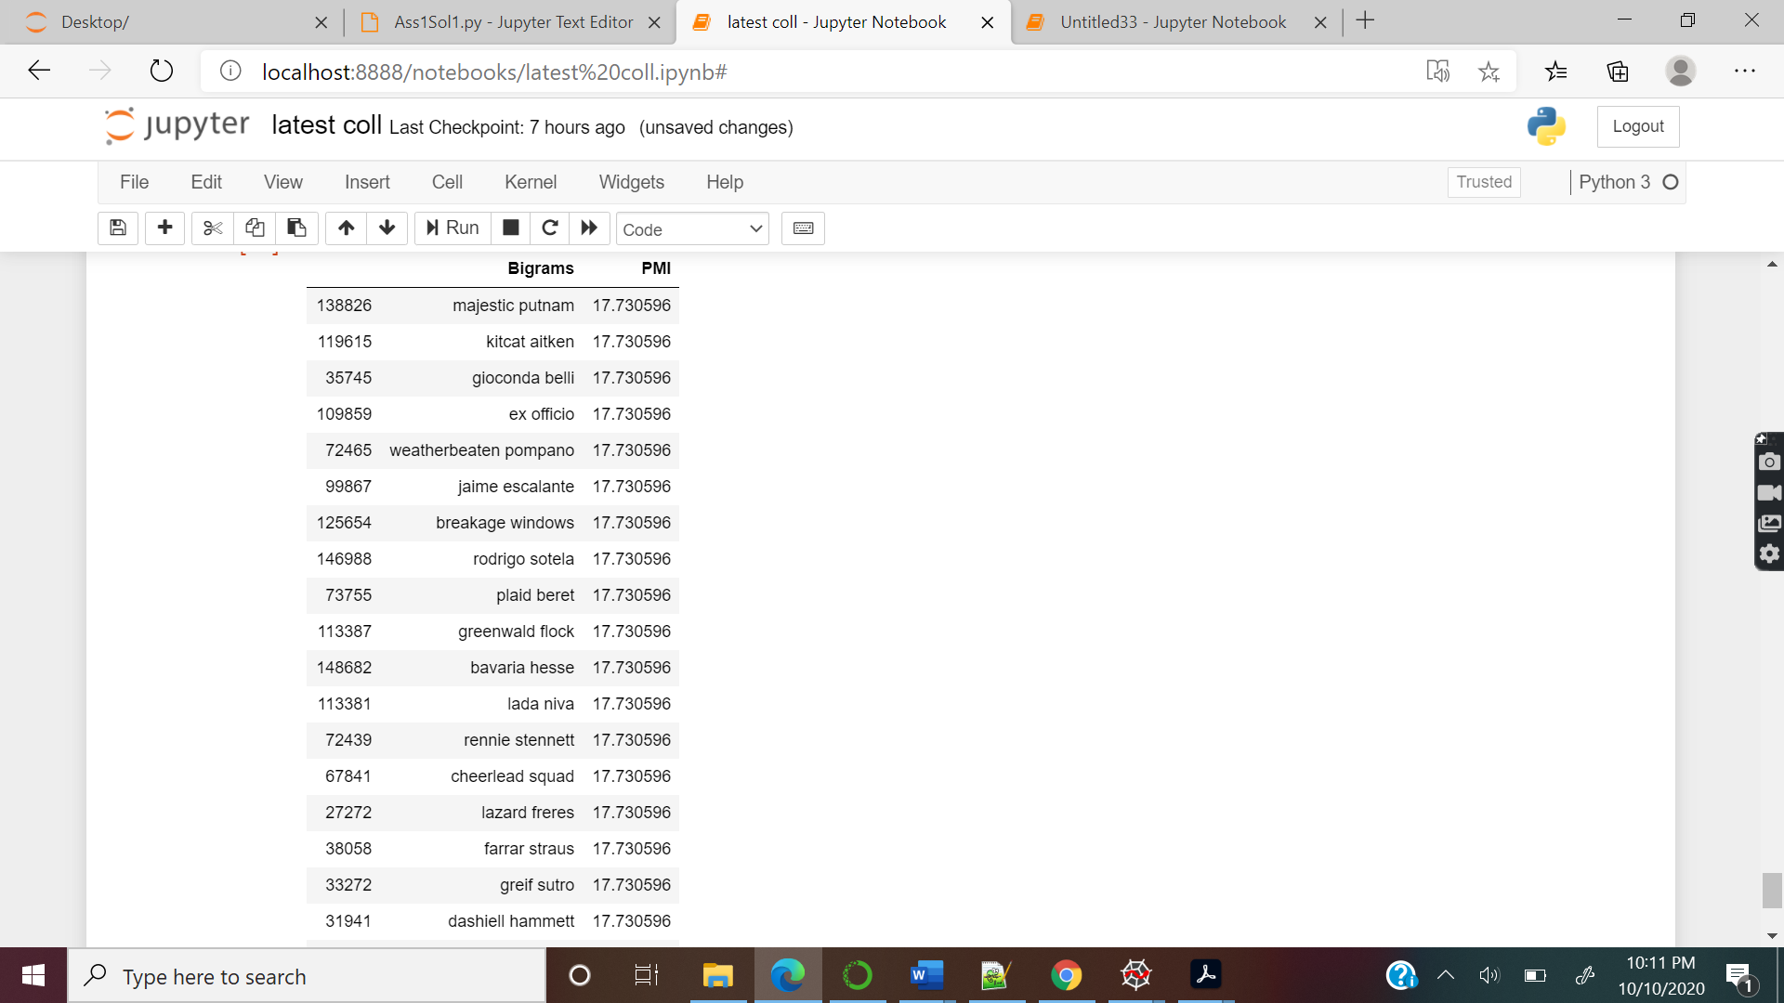

I personally feel Chi Square test results are better than PMI results. As we can see in the screen shot like pong pagong, Piper Jaffray and so on are all collocation.